ASSIGNMENT-1

KALAIARASI R

1. HOME AUTOMATION:-

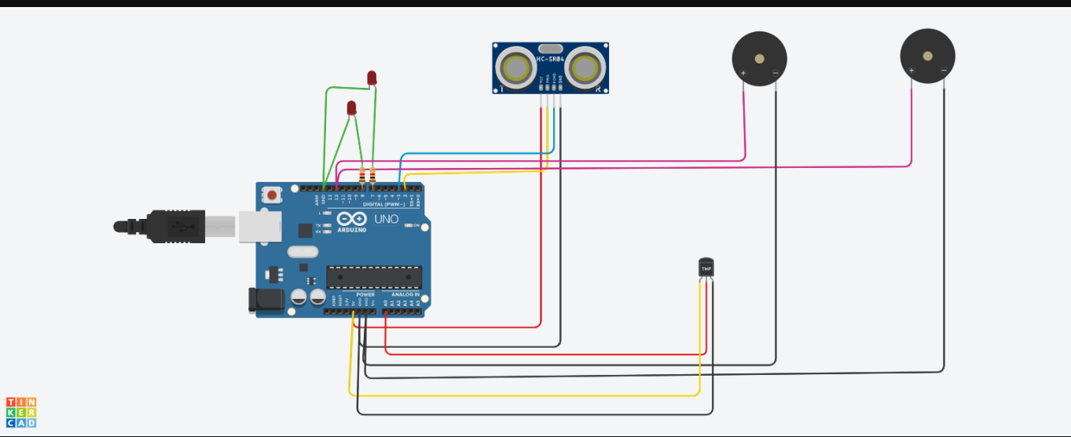

CODE:

|  |
| --- |
|  |
|  | int e=3;  int t=2; |
|  |  |
|  | void setup() |
|  | { |
|  | Serial.begin(9600); |
|  | pinMode(t,OUTPUT); |
|  | pinMode(e,INPUT); |
|  | pinMode(12,OUTPUT); |
|  | } |
|  |  |
|  | void loop() |
|  | { |
|  | //ultrasonic sensor |
|  | digitalWrite(t,LOW); |
|  | digitalWrite(t,HIGH); |
|  | delayMicroseconds(10); |
|  | digitalWrite(t,LOW); |
|  | float dur=pulseIn(e,HIGH); |
|  | float dis=(dur*0.0343)/2; |
|  | Serial.print("Distance is: "); |
|  | Serial.println(dis); |
|  |  |
|  | //LED ON |
|  | if(dis>=100) |
|  | { |
|  | digitalWrite(8,HIGH); |
|  | digitalWrite(7,HIGH); |
|  | } |
|  |  |
|  | //Buzzer For ultrasonic Sensor |
|  | if(dis>=100) |
|  | { |
|  | for(int i=0; i<=30000; i=i+10) |
|  | { |
|  | tone(12,i); |
|  | delay(1000); |
|  | noTone(12); |
|  | delay(1000); |
|  | } |
|  | } |
|  |  |
|  |  |
|  |  |
|  |  |
|  | //Temperate Sensor |
|  | double a= analogRead(A0); |
|  | double t=(((a/1024)*5)-0.5)*100; |
|  | Serial.print("Temp Value: "); |
|  | Serial.println(t); |
|  | delay(1000); |
|  |  |
|  |  |
|  | //LED ON |
|  | if(t>=100) |
|  | { |
|  | digitalWrite(8,HIGH); |
|  | digitalWrite(7,HIGH); |
|  | } |
|  |  |
|  | //Buzzer for Temperature Sensor |
|  | if(t>=100) |
|  | { |
|  | for(int i=0; i<=30000; i=i+10) |
|  | { |
|  | tone(12,i); |
|  | delay(1000); |
|  | noTone(12); |
|  | delay(1000); |
|  | } |
|  | } |
|  |  |
|  | //LED OFF |
|  | if(t<100) |
|  | { |
|  | digitalWrite(8,LOW); |
|  | digitalWrite(7,LOW); |
|  | } |
|  | } |